Static Polymorphism

* The response to a function is determined during compile time

Dynamic Polymorphism

* Decided during run-time

namespace i.e, area => 1 dll => internal access modifier affecting the code produced here

Delegates for callbacks - research this

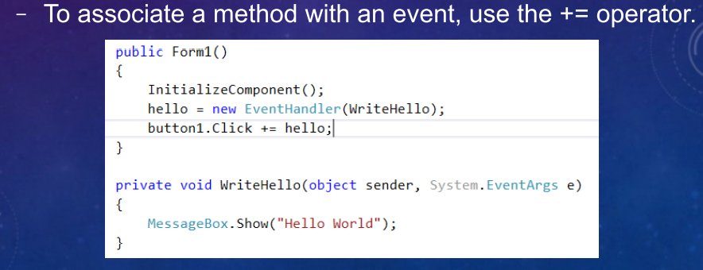

## Extension Methods

Extension methods are defined as static methods but are called by using instance method syntax. Their first parameter specifies which type the method operates on. The parameter is preceded by the [this](https://docs.microsoft.com/en-us/dotnet/csharp/language-reference/keywords/this) modifier. Extension methods are only in scope when you explicitly import the namespace into your source code with a using directive.

The following example shows an extension method defined for the [System.String](https://docs.microsoft.com/en-us/dotnet/api/system.string) class. It's defined inside a non-nested, non-generic static class:

namespace ExtensionMethods

{

public static class MyExtensions

{

public static int WordCount(this String str)

{

return str.Split(new char[] { ' ', '.', '?' },

StringSplitOptions.RemoveEmptyEntries).Length;

}

}

}

static => cannot new Class() it. Cannot change it.

Serialization

* Turning object into some form of data that can be stored or transmitted

Stack vs Heap

* Stack - Last in first out, self-maintaining without the need of external garbage collection
* Heap - Allows random-access at any time, need to be handled by the garbage collector

Boxing vs Unboxing

* Expensive operation to transfer from stack to heap or vice versa

int i = 123; // a value type

object o = i; // boxing

int j = (int)o; // unboxing

String test = “text”;

var text = test ?? “Default value if null”;

if test is null then it will print the text. If not, it will be the text value.

All reference types will default to null. int, char, double and bool doesn’t default to null.

String Comparison => string_var.Equals(another_string_var, [StringComparison.OrdinalIgnoreCase]);

Casting

* Use as keyword vs using (cast) because it will return null if the cast is invalid
* i.e, variable as String;

Params as a parameter

void Function(params int[] value) { }

Function(1, 2, 3, 4, 5);

Use String.Format() instead of +’s because null values will throw an exception.

You can also use StringBuilder().

Verbatim String Literals

* Simplify string with escape characters by putting an @ in front of it
* Doesn’t work with quotes
* @’String with an \ escape character’

Object Initializers

new ObjectClass {

Id = 1;

Name = Nik;

}

Printing Array

* Requires manually creating a string
* int data[] = { 1, 2, 3, 4 }
* String.Join(“, “, data);

try catch finally block

* catch will only run if there’s an exception
* finally will run regardless

Using keywords as variable names

var @return = “A string variable name return”;

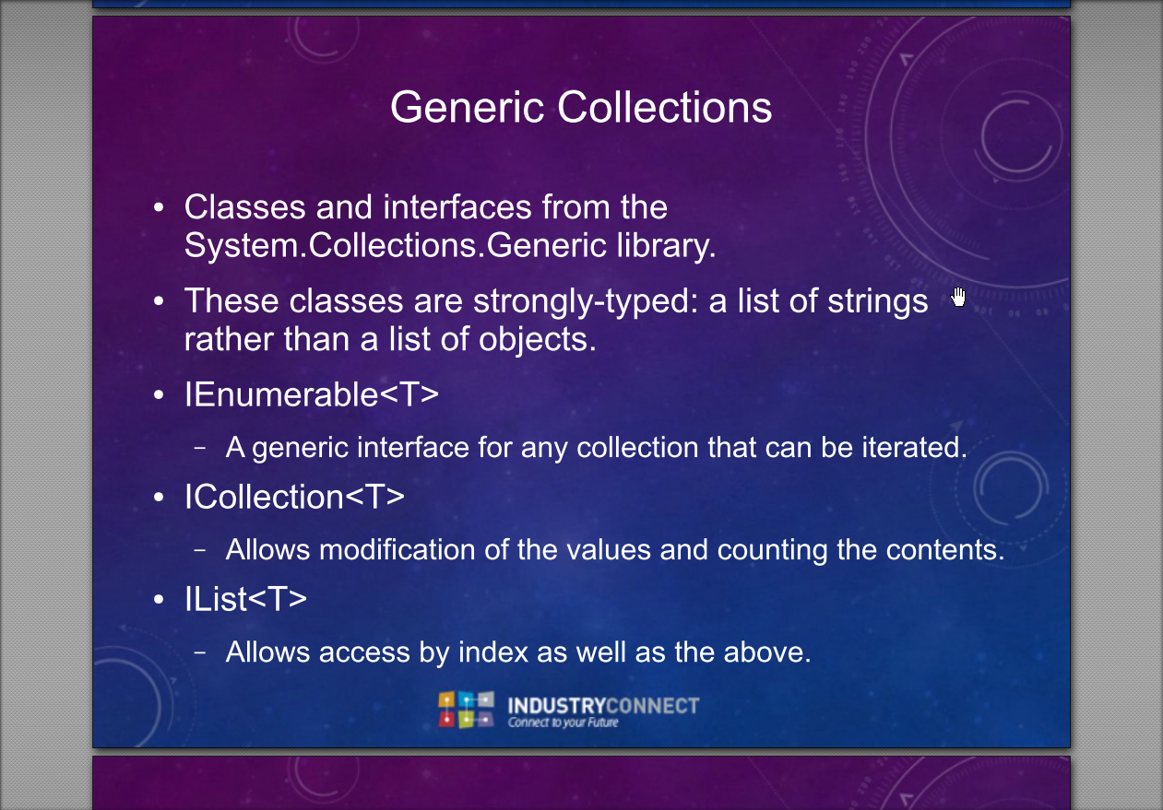

SQL

Schema is akin to namespaces

The table containing the foreign key is the 'child' table and

the table with the primary key is the 'parent' table.

Self-referencing Relationship is one between the same table. I.e, a customer can refer multiple other customers in a table for a referral program.

Or an employee that’s referencing the same manager who is also an employee.

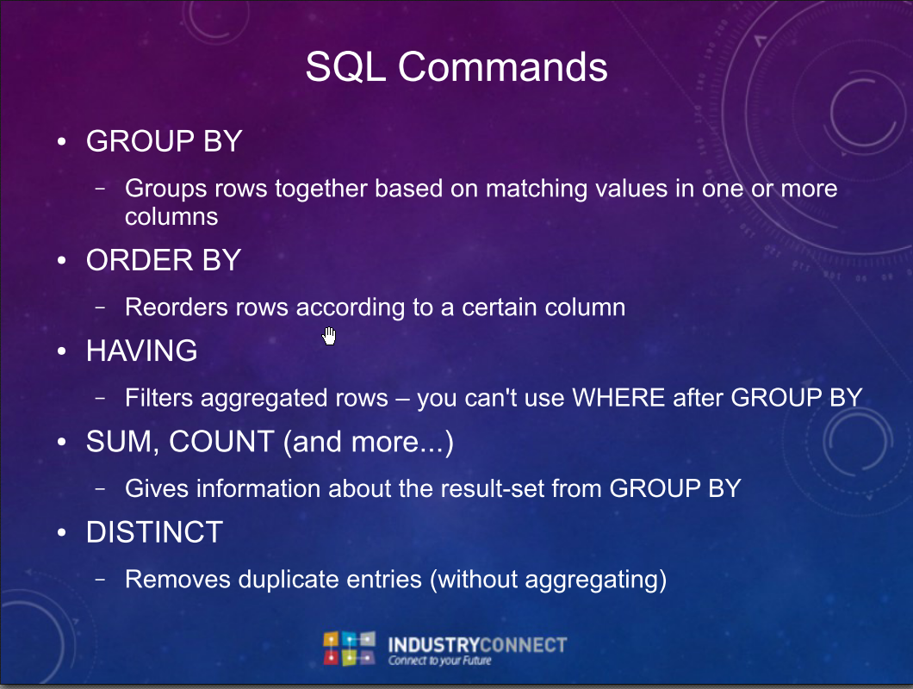

CREATE

ADD

ALTER

DROP

USE

DATABASE

TABLE

COLUMN

SELECT

WHERE

FROM

ORDER BY … ASC DESC

GROUP BY

COUNT(X)

SUM

Sql Join - join two tables together to query on the results

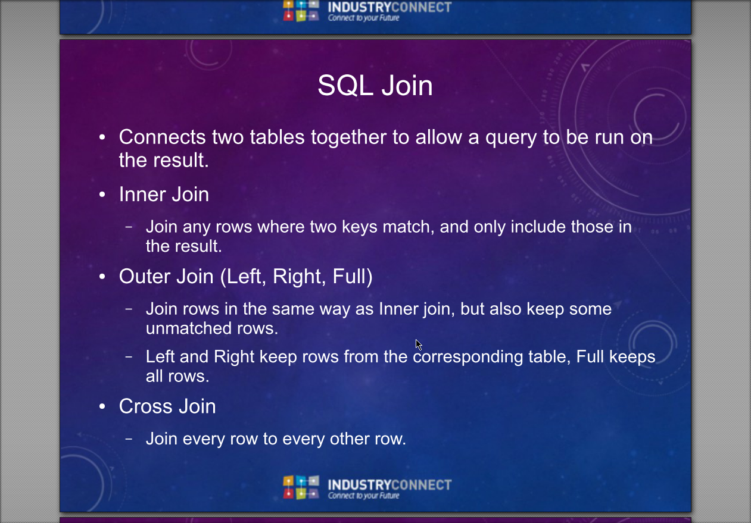

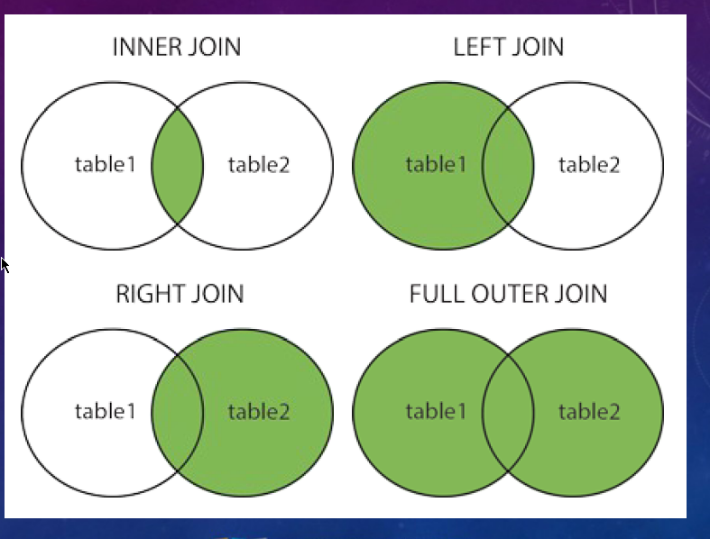

SELECT orders.orderid, customers.customername

FROM Customers

INNER JOIN Orders on customers.customerid = orders.customerid

*Customers.CustomerId and Orders.Customerid is the same. That’s why we can join the two tables together.

SELECT ict.Students, s.Name

-- industryconnecttable is left table

FROM dbo.IndustryConnectTable ict

-- students is right table

INNER JOIN dbo.Students s

-- ON is the merged data (inner)

ON ict.id = s.id;

Cross join = every combination is accounted for

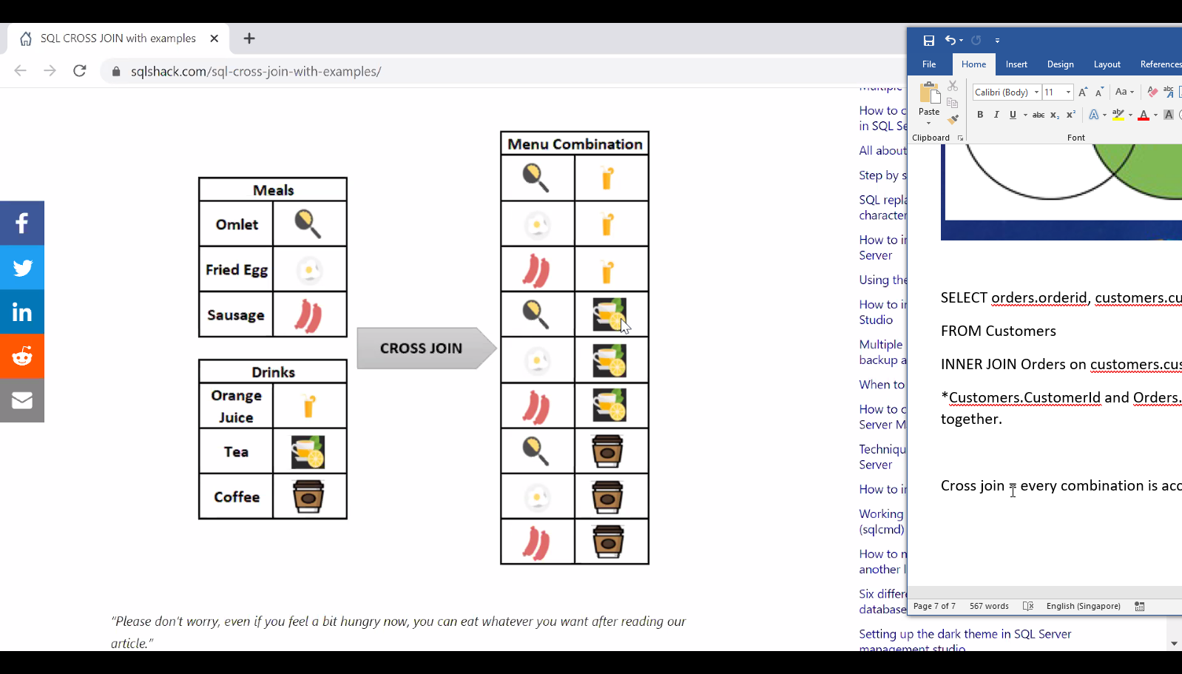

-- Select what you want to show in the output

SELECT orders.customerid, customers.customerid, customername, orderid

-- from where

FROM orders

-- Note: The INNER JOIN keyword selects

-- all rows from both tables as long as

-- there is a match between the columns.

-- If there are records in the "Orders"

-- table that do not have matches in

-- "Customers", these orders will not be shown!

inner join customers

-- Whatever row that satisfies the following equation is shown

on orders.customerid == customers.customerid

SQL Server Defaults

prop DEAFULT ‘Default value here’

CREATE TABLE Persons (

ID int NOT NULL,

LastName varchar(255) NOT NULL,

FirstName varchar(255),

Age int,

City varchar(255) DEFAULT 'Sandnes'

);

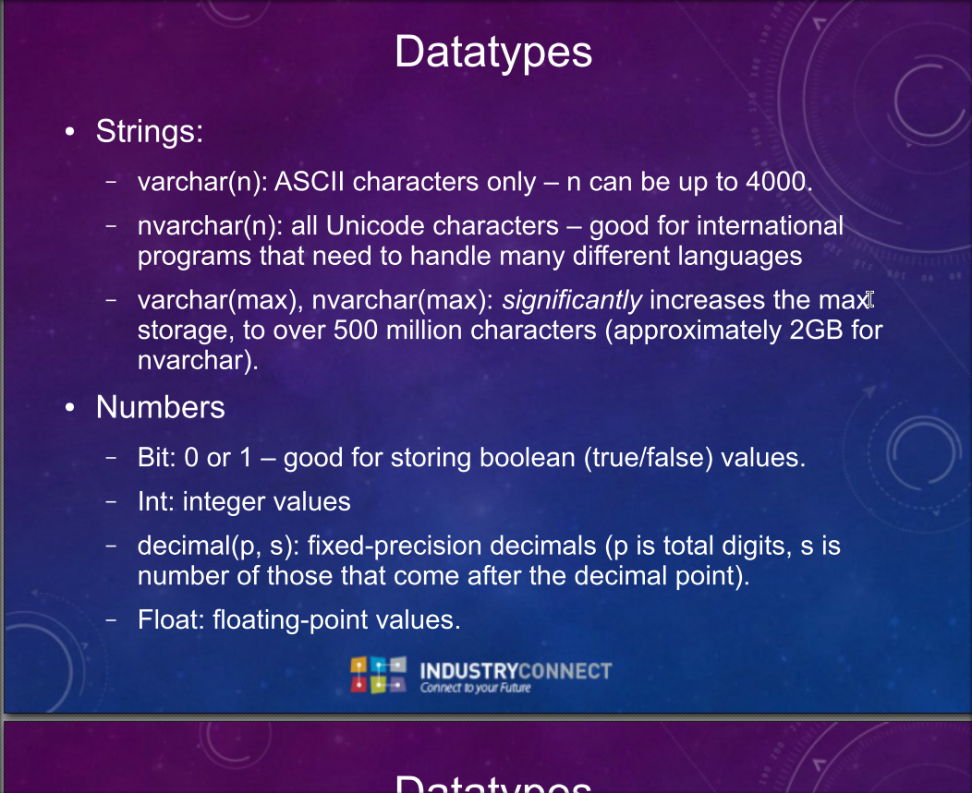

nvarchar(n) where n <=4000

varchar(max) - oncreases the max storage to over 500 million characters (2gb for nvarchar)

decimal(p, s) where p = total digits, s = how many decimal point (.ss)

IDENTITY(seed, increment) where seed is the starting number and increment is how much the number will increase on each row added

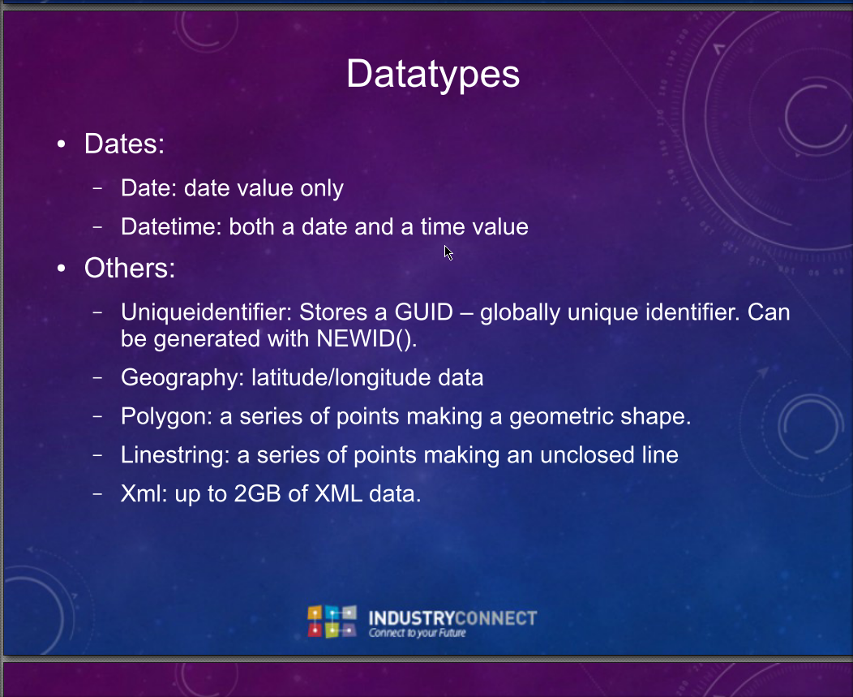

SQL User-defined Functions

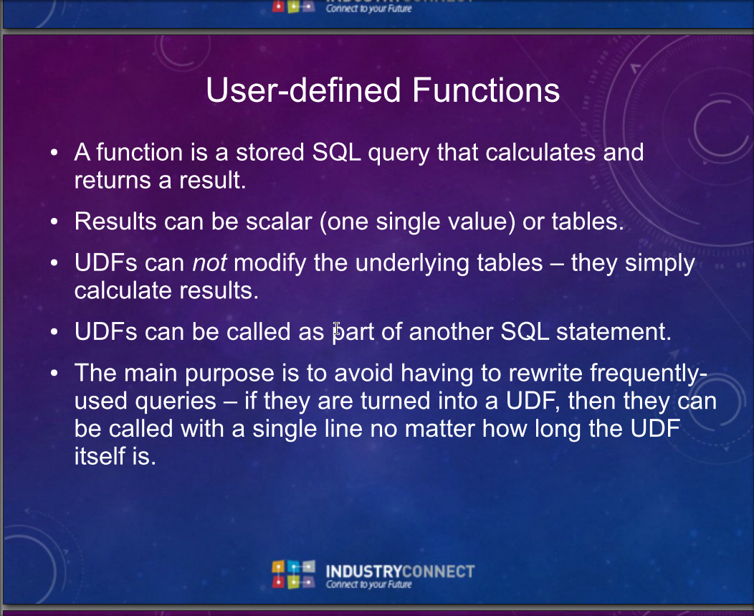

CREATE FUNCTION Function_Name(@Parameter_Name Data_Type, … @Parameter_Name Data_Type)

RETURNS Data_Type

AS

BEGIN

-- Function Body

RETURN (SELECT @firstName + SPACE(2) + @lastName)

END

// Call function

dbo.FunctionName(param1, param2 …) AS [Name]

…

where the value that the function return will be under column NAME.

Can also be used to return a TABLE:

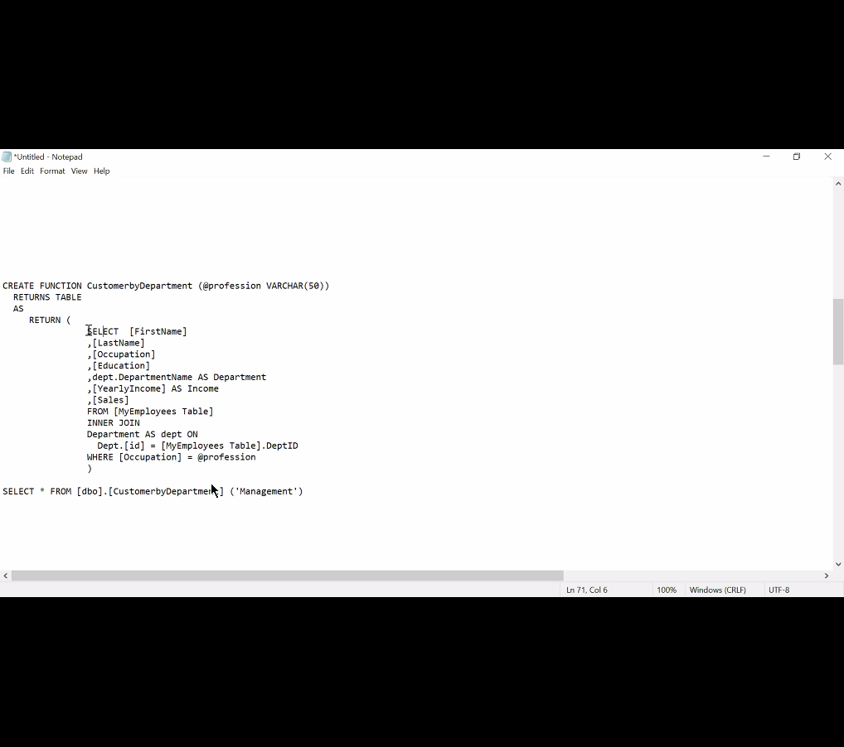

Views - virtual table that can be used to update data only if they directly pull data from tables and only one table needs to be modified

CREATE VIEW view_name AS  
SELECT column1, column2, ...  
FROM table_name  
WHERE condition;

For example:

-- Create view

CREATE VIEW industryconnectstudentsview AS

SELECT * FROM dbo.Students

-- Query the view

SELECT * FROM dbo.industryconnectstudentsview

-- Drop view

DROP VIEW dbo.industryconnectstudentsview

Stored Procedures

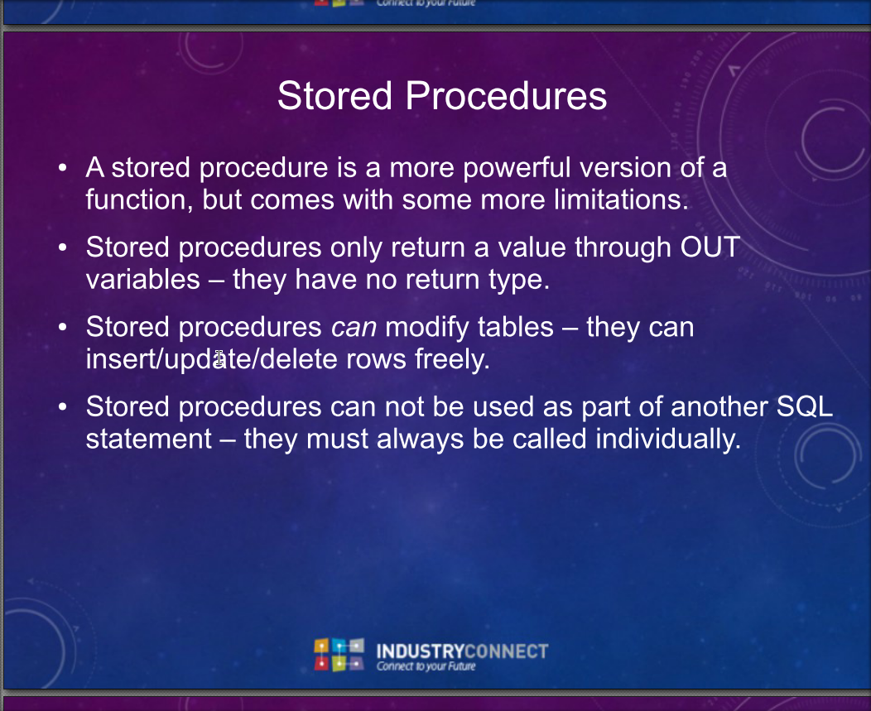

CREATE PROCEDURE procedure_name  
AS  
sql_statement  
GO;

Index

* by default the primary key

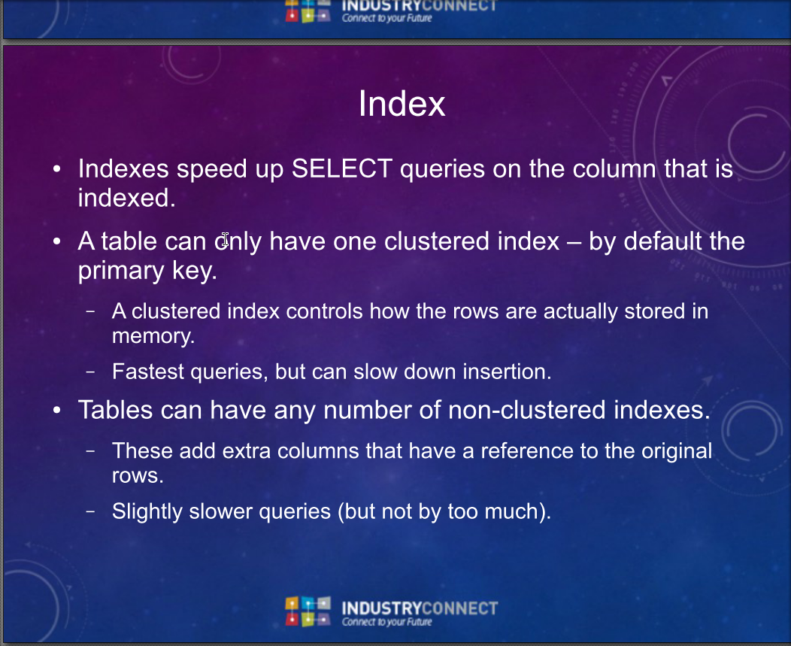

The basic syntax of a **CREATE INDEX** is as follows.

CREATE INDEX index_name ON table_name;

The INDEX is used to create and retrieve data from the database very quickly. An Index can be created by using a single or group of columns in a table. When the index is created, it is assigned a ROWID for each row before it sorts out the data.

Proper indexes are good for performance in large databases, but you need to be careful while creating an index. A Selection of fields depends on what you are using in your SQL queries.

There are two types of Indexes in SQL Server:

Clustered Index

A clustered index defines the order in which data is physically stored in a table. Table data can be sorted in only way, therefore, there can be only one clustered index per table. In SQL Server, the primary key constraint automatically creates a clustered index on that particular column.

Non-Clustered Index

A non-clustered index doesn’t sort the physical data inside the table. In fact, a non-clustered index is stored at one place and table data is stored in another place. This is similar to a textbook where the book content is located in one place and the index is located in another. This allows for more than one non-clustered index per table.

More info:

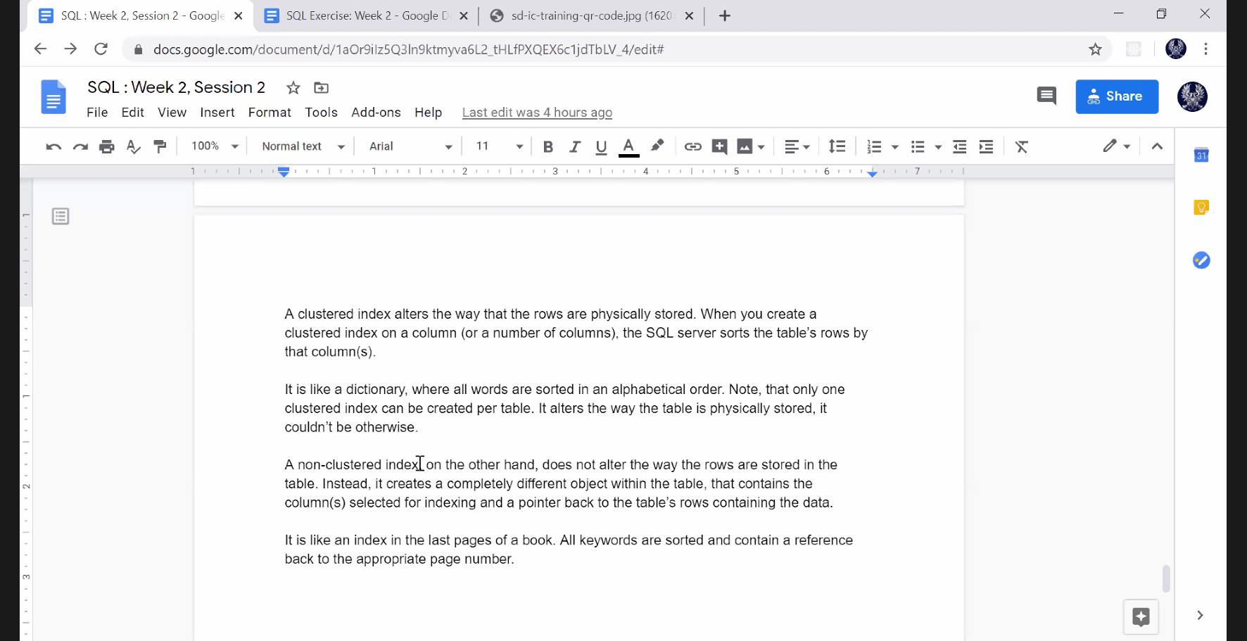

<https://docs.google.com/document/d/1aOr9iIz5Q3ln9ktmyva6L2_tHLfPXQEX6c1jdTbLV_4/edit>

### **Single-Column Indexes**

A single-column index is created based on only one table column. The basic syntax is as follows.

CREATE INDEX index_name

ON table_name (column_name);

## **The DROP INDEX Command**

An index can be dropped using SQL **DROP** command. Care should be taken when dropping an index because the performance may either slow down or improve.

The basic syntax is as follows −

DROP INDEX index_name;

Week 2 Exercises

<https://docs.google.com/document/d/1zrgqz_bxJ5TuOVmDrzb-kejuNnn7Vd8c89Zjolz72oQ/edit>

WHERE CITY ‘Sydney’ OR 'Auckland'

LINQ

* Known as Language Integrated Query
* Complex queries can be broken down and/or run against multiple datasources
* Allows queries against in-memory objects, removing the need for complex nested foreach loops

Syntax:

* Query syntax
  + for c in Customers
  + select c;
* Lambda syntax
  + () => {}

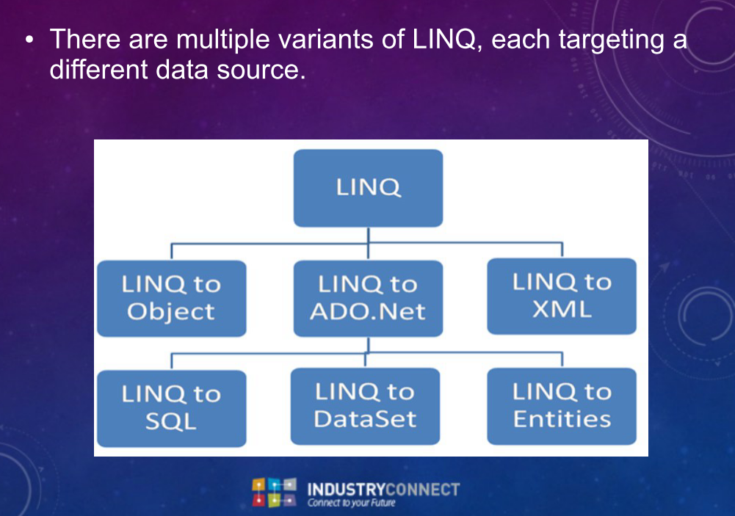

Linq methods

* .Where(x => x.ID > 5)
* .Select (x => x.Child) || .Select(x => new {})
* .SelectMany(x => x.ChildCollection)
  + i.e, Customers.SelectMany(x => x.Orders) where orders is a set of child collections

Select(Func x) will show the values of x only

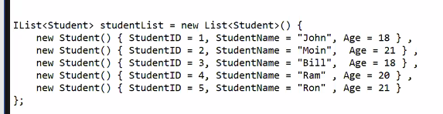

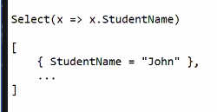

Customers.Select(x => new {x.CustomerID, x.CompanyName}) will select the two columns

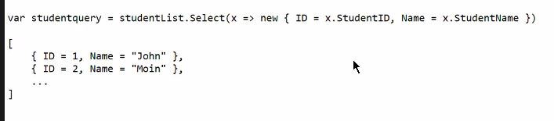

Transaction follows ACID Rule

Atomic

Consistent

Independent

Durable

Atomic means that if any 1 transaction fails, the whole transaction fails.

Get the database context:

public class HomeController : Controller

    {

        private ICWeek2TutorialEntities context = new ICWeek2TutorialEntities();

Week 4

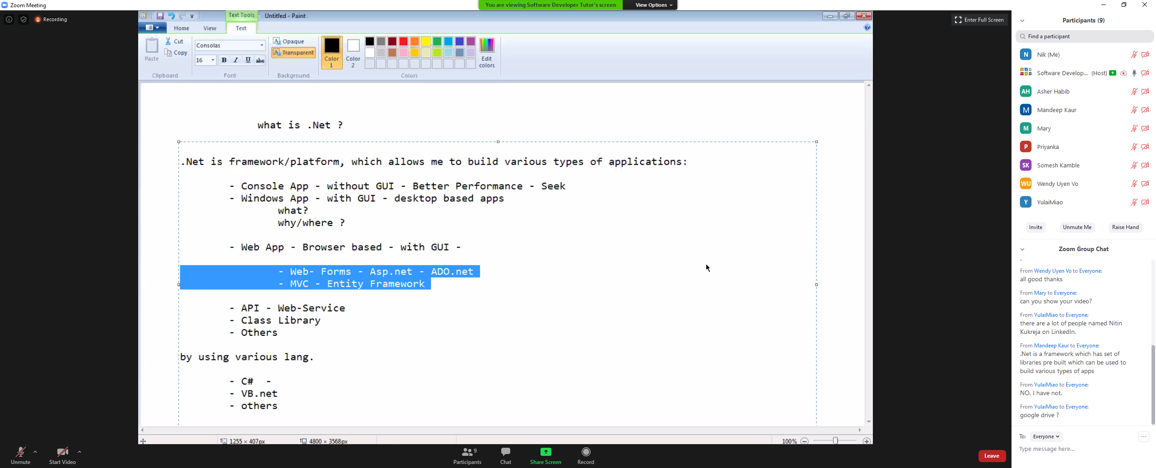

Types of Controls:

* Server Controls
  1. Created by Dot Net
  2. Can be executed only on the server
  3. <asp:Button …
* HTML Controls (Client controls)
  1. <a, <button, <form …

Elements are marked with the runat="server" attribute. This will give access to the control's server-side API.

Server controls can be referenced from the .cs file because it is technically made with C# instead of HTML controls.

Browser only understand HTML, Javascript, VBScript so all server controls written will be converted to HTML controls.

Why Web Forms? Can drag and drop controls easily to the page.

Architecture of Web Forms

C# controls are executed on the server and it will return the page back to client as html controls because browser does not understand C# codes.

Server has to do: Code execution, convert server controls to html controls

Makes server slow if there are a lot of clients connecting and making requests because it has to do those stuffs above.

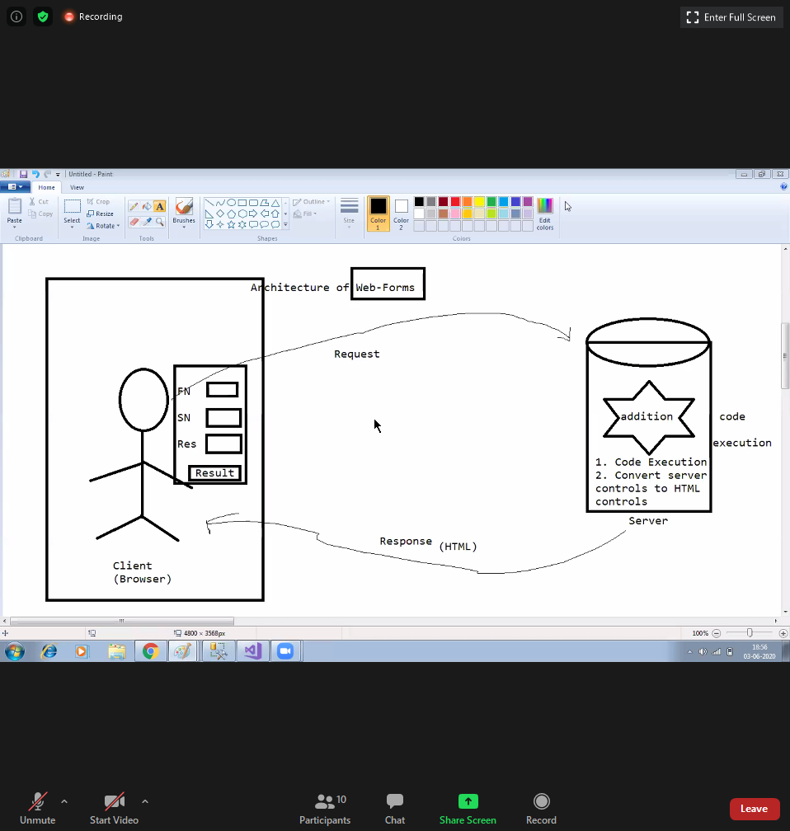

Week 6

ADO.net

* Data access library to create and manage connections to different range of data source

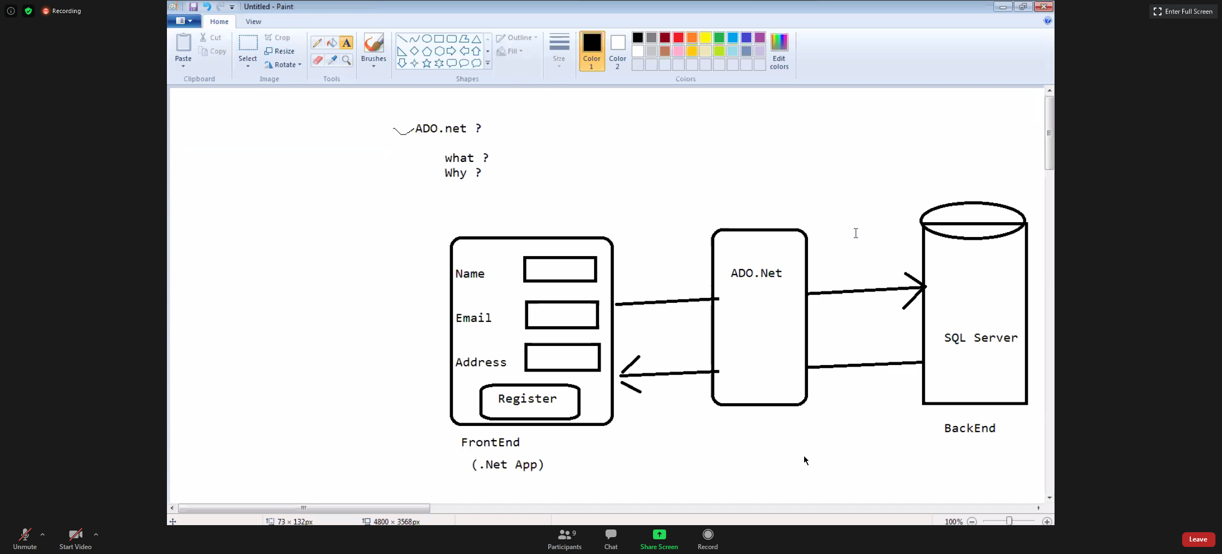

Class Library

* A collection of Namespaces + Classes + Functions

To use ADO.NET:

using System.Data;

using System.Data.SqlClient;

// Create and open the connection in a using block. This

// ensures that all resources will be closed and disposed

// when the code exits.

using (SqlConnection connection =

    new SqlConnection(connectionString))

{

    // Create the Command and Parameter objects.

    SqlCommand command = new SqlCommand(queryString, connection);

    command.Parameters.AddWithValue("@pricePoint", paramValue);

    // Open the connection in a try/catch block.

    // Create and execute the DataReader, writing the result

    // set to the console window.

    try

    {

        connection.Open();

        SqlDataReader reader = command.ExecuteReader();

        while (reader.Read())

        {

            Console.WriteLine("\t{0}\t{1}\t{2}",

                reader[0], reader[1], reader[2]);

        }

        reader.Close();

    }

    catch (Exception ex)

    {

        Console.WriteLine(ex.Message);

    }

    Console.ReadLine();

}

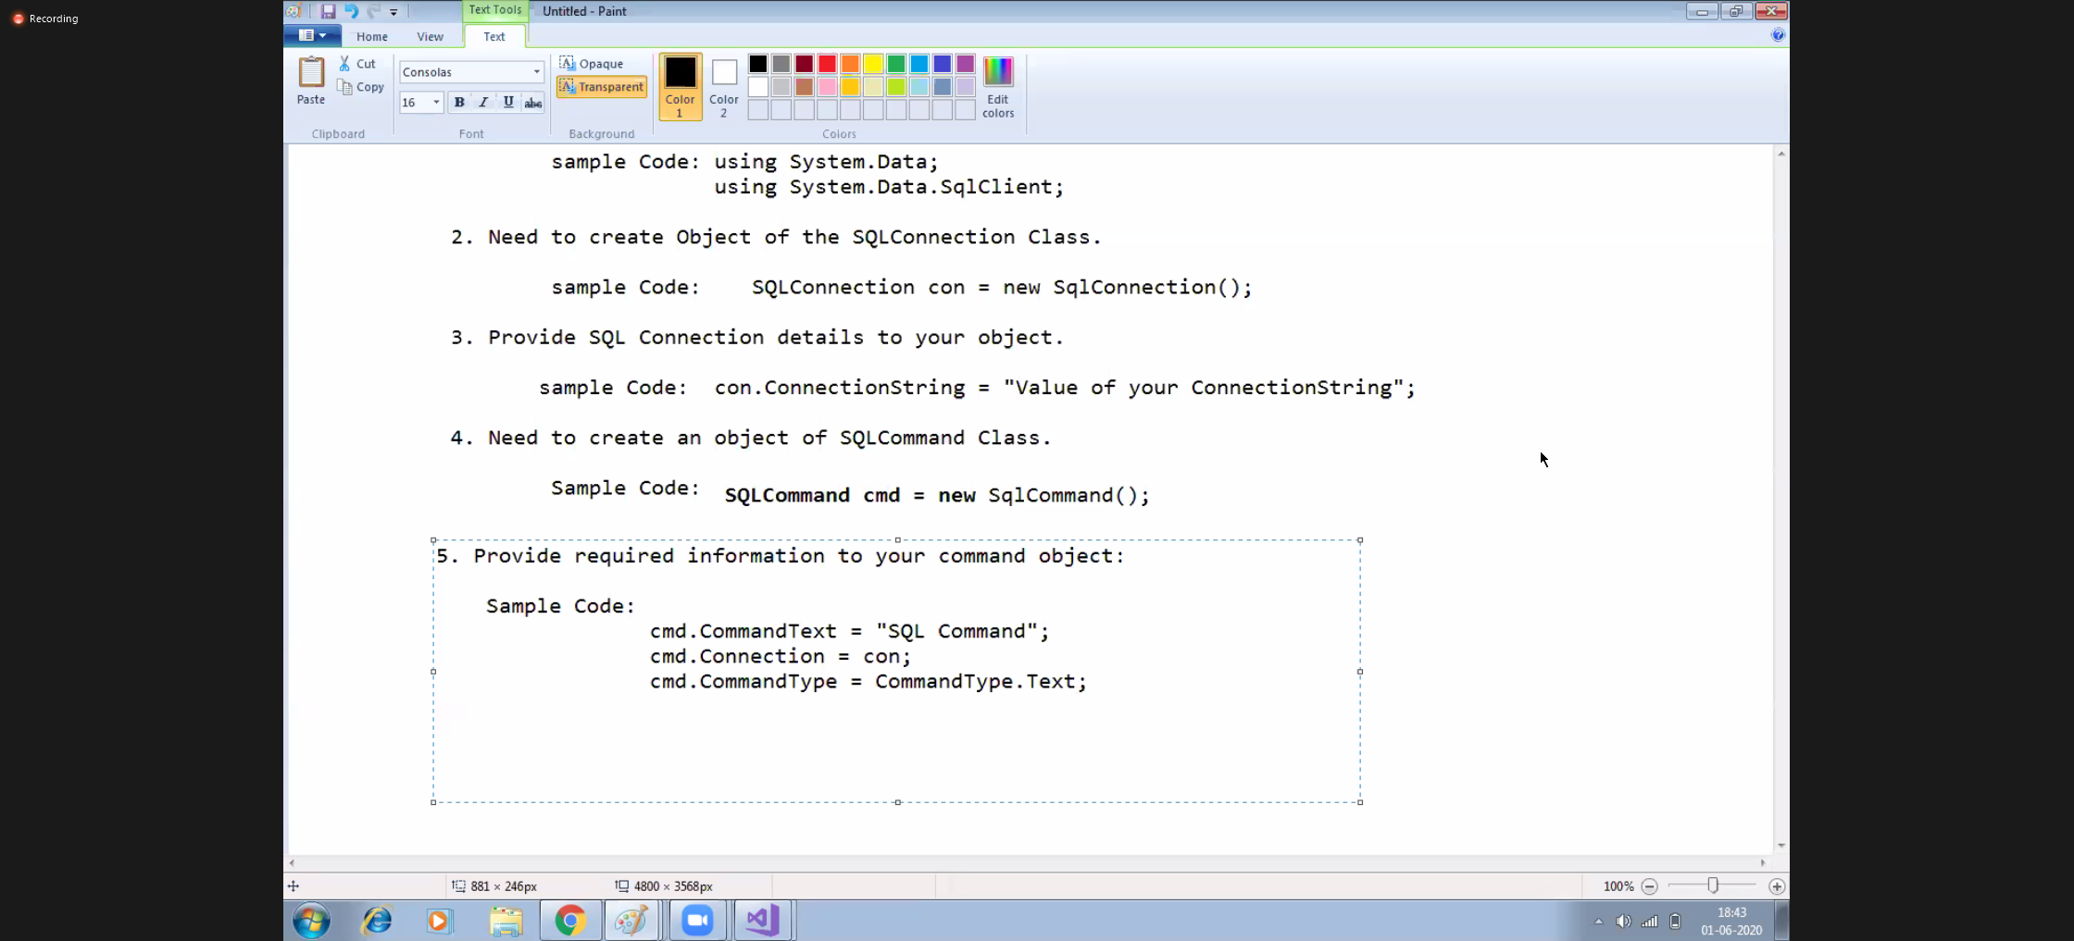

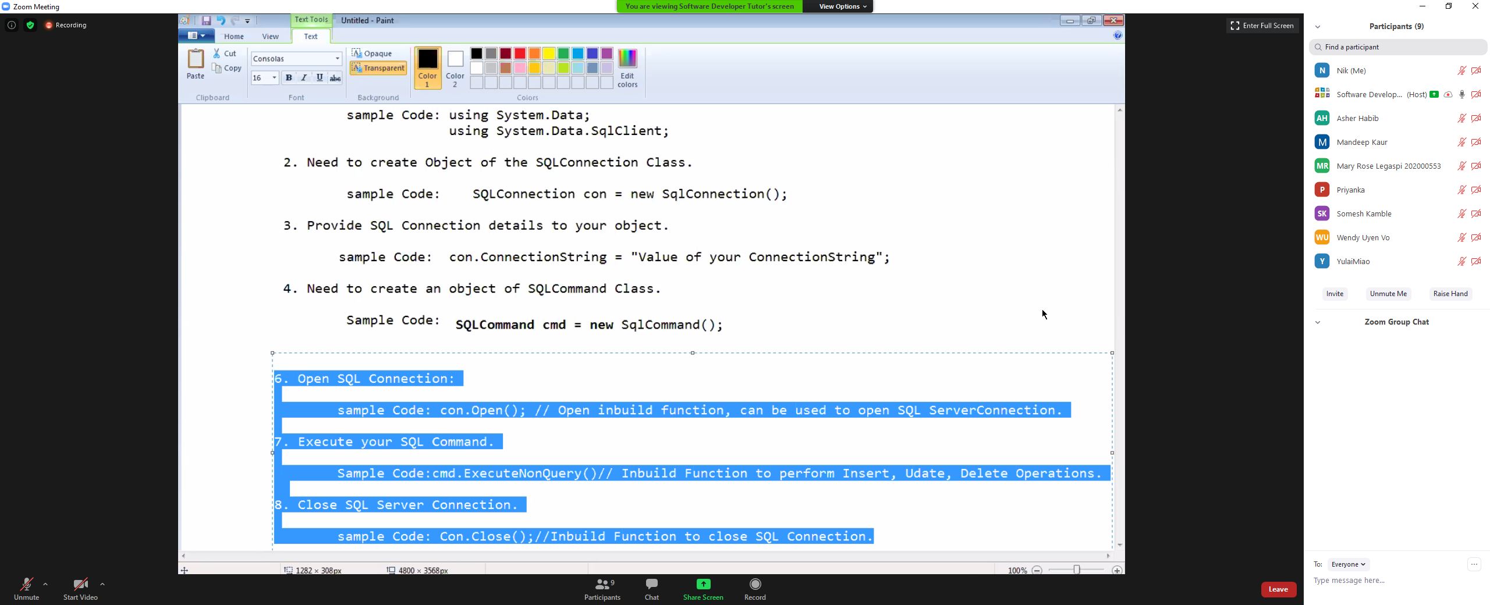

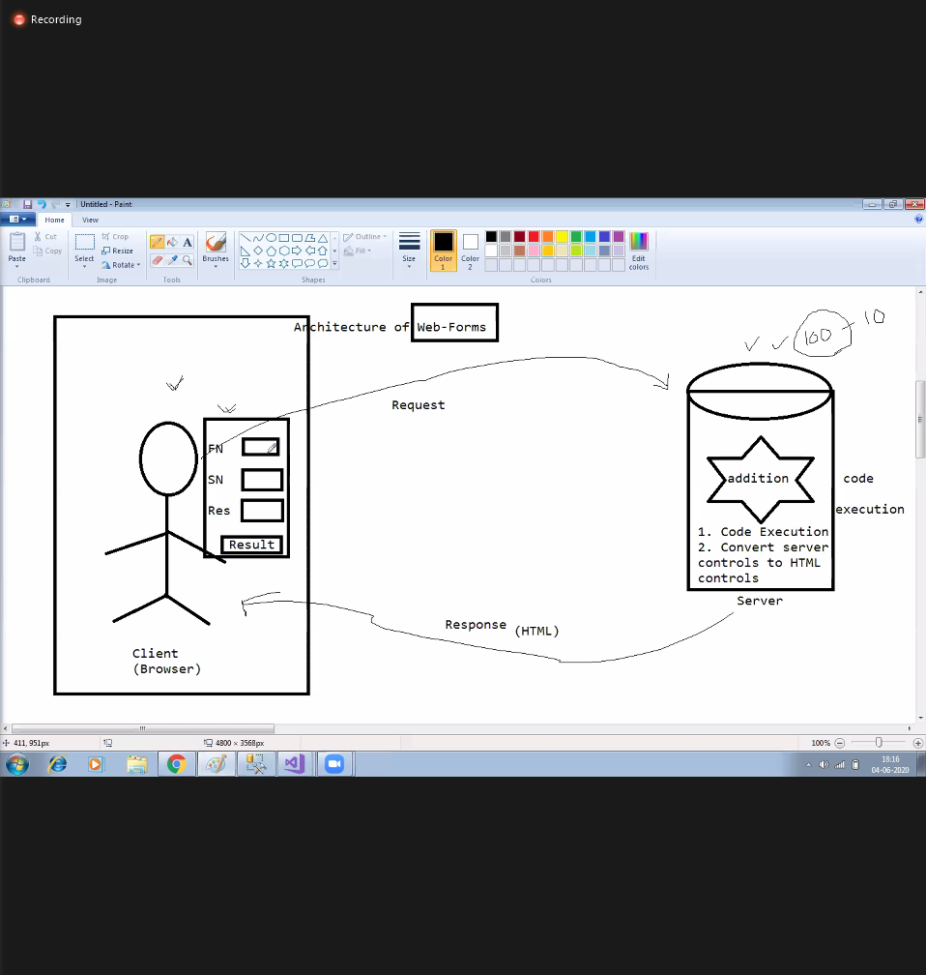

Week 5

What is MVC?

It’s a software architecture pattern.

Model - Represents data

View - aspx, aspx.cs, html, jsx - (primarily have html but may have codes too)

Controller - Write codes here

Why MVC?

Why from Web forms to MVC?

MVC does not lag the server like Web Forms does.

URL

<https://serverurl/controller/actionmethod/id>

RouteConfig

Define friendly url pattern structure rather than use FileNames and or instructions

routes.MapRoute(

                name: "Default",

                url: "{controller}/{action}/{id}",

                defaults: new { controller = "Home", action = "Index", id = UrlParameter.Optional }

            );

BundleConfig

Bundling is a new feature in ASP.NET 4.5 that makes it easy to **combine or bundle multiple files into a single file**. You can create CSS, JavaScript and other bundles. Fewer files means fewer HTTP requests and that can improve first page load performance.

Download in one go.

FilterConfig

In ASP.NET MVC, a user request is routed to the appropriate controller and action method. However, there may be circumstances where you want to execute some logic before or after an action method executes. ASP.NET MVC provides filters for this purpose.

Pass data from View to Controller via Models

i.e class {

properties

}

Steps:

1. Create your Model that will define the data that you want to exchange
2. Create View and Controller
3. Add Reference of the Model into your View 🡪
   1. @model Week_5_MVC.Models.CalculatorModel (This will bind the model between the View and The Controller)
4. Write the controller

@Html.LabelFor 🡨 used to bind the control to the model

@Html.LabelFor(m => m.Title)

<!-- Add the model -->

@model Week_5_MVC.Models.CalculatorModel

<!-- Will cleanup after -->

@using (Html.BeginForm("Calculator", "Calculator", FormMethod.Post))

{

    <h2>Calculator</h2>

    @Html.LabelFor(m => m.Title)

    <div>

        @Html.Label("First Number")

        @Html.TextBoxFor(m => m.FirstNumber)

        @Html.Label("Operation")

        @Html.TextBoxFor(m => m.Operation)

        @Html.Label("Second Number")

        @Html.TextBoxFor(m => m.SecondNumber)

        @Html.Label("Results")

        @Html.DisplayFor(m => m.Result)

        <!-- Posting to Calculator() in Controller -->

        <input type="submit" value="Submit" />

    </div>

// CalculatorModel model is linked to View when it uses @model in the View

        public ActionResult Calculator(CalculatorModel model)

        {

            Debug.WriteLine(model.Operator);

            switch (model.Operator)

            {

                case Operation.Subtraction:

                    model.Result = model.FirstNumber - model.SecondNumber;

                    break;

                case Operation.Multiplication:

                    model.Result = model.FirstNumber * model.SecondNumber;

                    break;

                case Operation.Division:

                    model.Result = model.FirstNumber / model.SecondNumber;

                    break;

                default:

                    model.Result = model.FirstNumber + model.SecondNumber;

                    break;

            }

            // Returns a view

            return View(model);

        }